Question 1 :

<!DOCTYPE html>

<html>

<body>

<script language="javascript" type="text/javascript">

        document.write(navigator.userAgent);

    </script>

</body>

</html>

Screenshot:

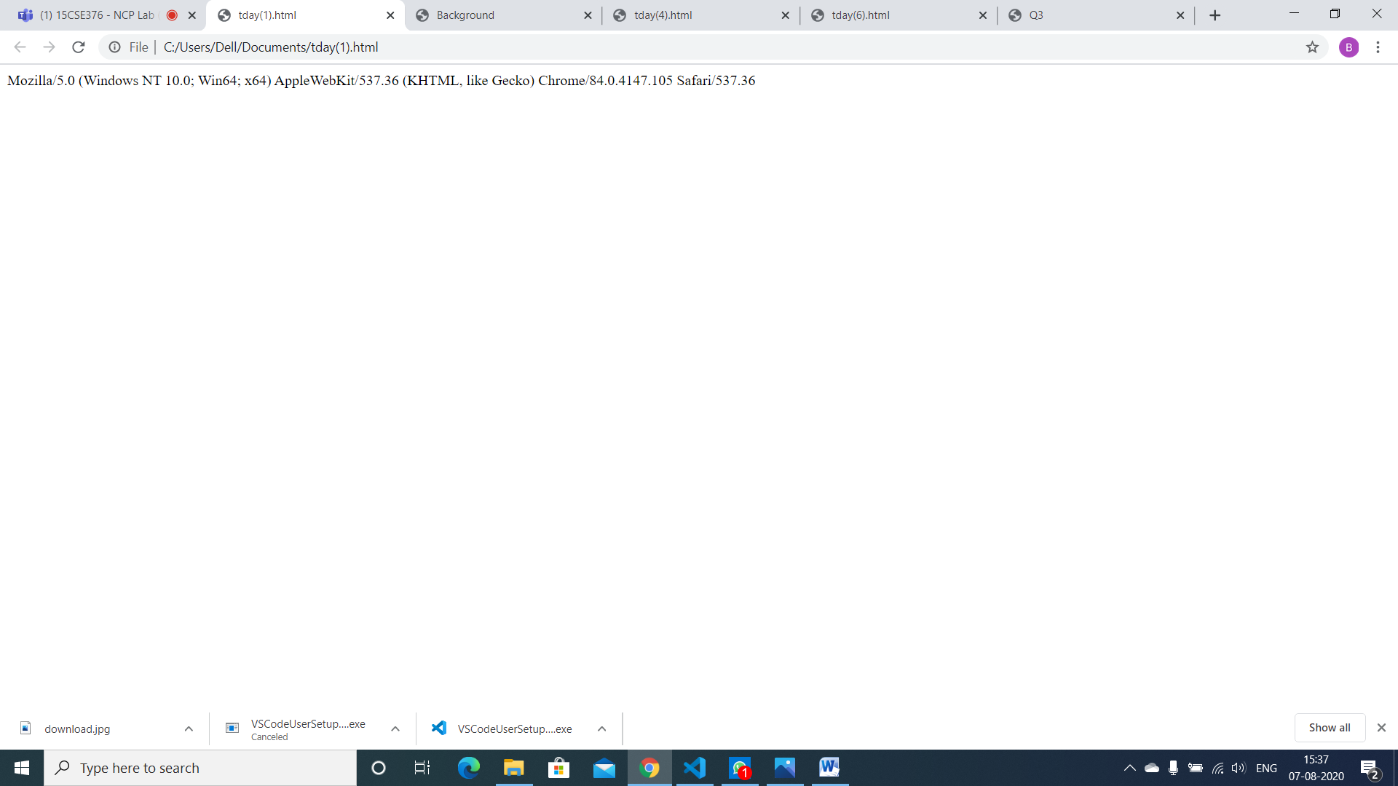

2 question :

<!DOCTYPE html>

<html>

<head>

    <title>Background</title>

</head>

<body>

    <script language="javascript" type="text/javascript">

        function changecolour()

        {

            document.body.style.background="orange"

        }

        function oldcolour()

        {

            document.body.style.background="green"

        }

    </script>

    <img id="img1" onmouseover="changecolour()" onmouseout="oldcolour()" src="dukesball.jpg" width="300px">

</body>

</html>

Output:

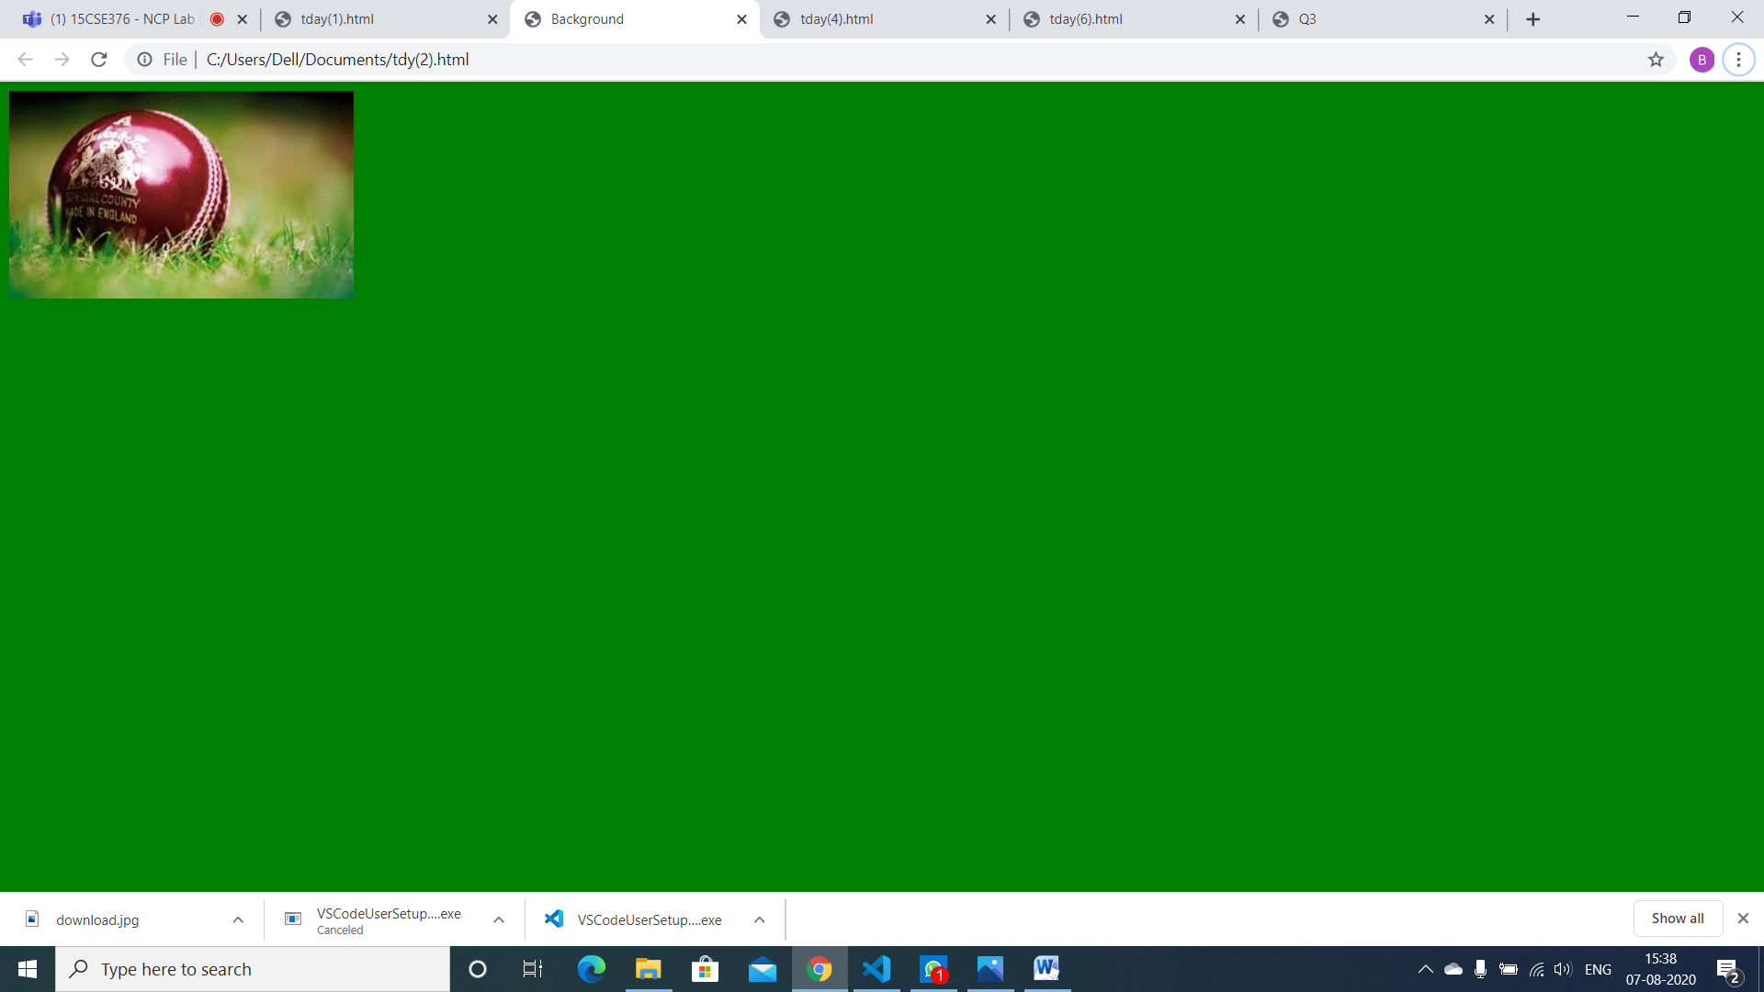

6 question :

<!DOCTYPE html>

<html>

<head>

    <script type="text/javascript">

        var principal = 0;

        var interestRate = 0;

        var timesCompounded = 0;

        var termOfLoan = 0;

        var amount = 0;

        function simpleInterest() {

            event.preventDefault();

            var principal = parseFloat(document.getElementById("principalSimple").value);

            var interestRate = parseFloat(document.getElementById("interestSimple").value);

            interestRate = interestRate / 100;

            var termOfLoan = parseFloat(document.getElementById("termSimple").value);

            var simpleInt = principal * interestRate * termOfLoan;

            var amount = (principal + simpleInt).toFixed(2);

            document.getElementById("siOutput-01").innerHTML = "Interest: " + simpleInt.toFixed(2)+"/-";

            document.getElementById("siOutput-02").innerHTML = "Total plus interest: " + amount+"/-";

        }

        function compoundInterest() {

            event.preventDefault();

            var principal = parseFloat(document.getElementById("principalCompound").value);

            var interestRate = parseFloat(document.getElementById("interestCompound").value);

            interestRate = interestRate / 100;

            var timesCompounded = parseFloat(document.getElementById("timesCompounded").value);

            var termOfLoan = parseFloat(document.getElementById("termCompound").value);

            var a = interestRate / timesCompounded;

            var b = 1 + a;

            var c = timesCompounded * termOfLoan;

            var d = Math.pow(b, c);

            var amount = (principal * d).toFixed(2);

            document.getElementById("ciOutput-01").innerHTML = "Interest: $" + (amount - principal).toFixed(2);

            document.getElementById("ciOutput-02").innerHTML = "Total plus interest: $" + amount;

}

    </script>

</head>

<body>

        <div class="jumbotron">

        <h1 class="text-center display-4"> Interest Calculator</h1>

        <hr>

    <div class="container" id="simple-interest">

    <h3>Simple Interest</h3>

    <p class="lead">Amount=i(Interst)+(prt)</p>

    <form id="siForm">

      <div class="form-group">

        <label for="principalSimple">Principal</label>

        <input type="text" class="form-control" id="principalSimple" placeholder="Enter the amount">

      </div>

      <div class="form-group">

        <label for="interestSimple">Interest Rate</label>

        <input type="text" class="form-control" id="interestSimple" placeholder="Example: --%">

      </div>

      <div class="form-group">

        <label for="termSimple">Loan Term(Years)</label>

        <input type="text" class="form-control" id="termSimple" placeholder="Example: 0-12 (must be in terms of years)">

      </div>

      <button type="submit" class="btn btn-primary" id="btnSimple" onclick="simpleInterest()">Submit</button>

    </form>

    <div>

      <p class="lead mt-3" id="siOutput-01"></p>

      <p class="lead mb-3" id="siOutput-02"></p>

    </div>

    <div class="text-center">

      <input class="btn btn-secondary btn-lg" type="button" value="Reset" onClick="document.getElementById('siForm').reset()">

    </div>

  </div>

  <br>

  <hr>

</body>

</html>

Output :

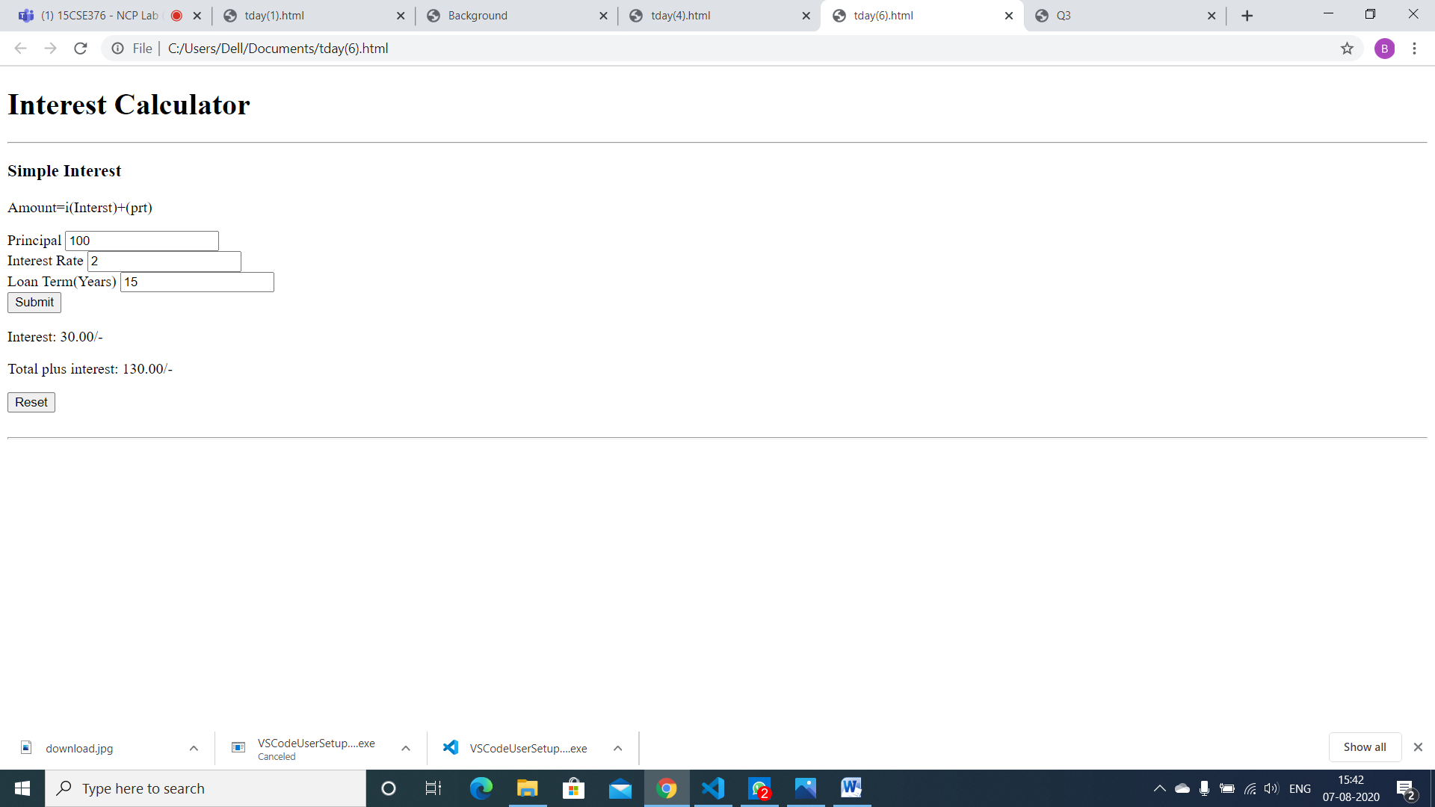

**4 question :**

<!DOCTYPE HTML>

<?xml version="1.0" encoding="UTF-8"?>

<html>

<head>

<title> Q3 </title>

</head>

<body style="background-color:white">

<h3 style="text-align:center; black"> Program to generate the Fibonacci Series </h3>

<script type="text/javascript">

 function fibonacci(num)

{

    var num1=0;

    var num2=1;

    document.write("",num1," ");

    document.write("",num2," ");

    var sum;

    var i=0;

    for (i = 1; i < num; i++)

    {

        sum=num1+num2;

        document.write("",sum," ");

        num1=num2;

        num2=sum;

    }

    return num2;

}

var num = prompt("Enter a number to generate the fibonacci series:", " ");

document.write("The number entered to generate the fibonacci series is: ",num, "<br/>");

document.write("The fibonacci series : ");

  document.write("fibonacci(num): "+fibonacci(num)+"<br>");

</script>

</body>

</html>

**Output :**

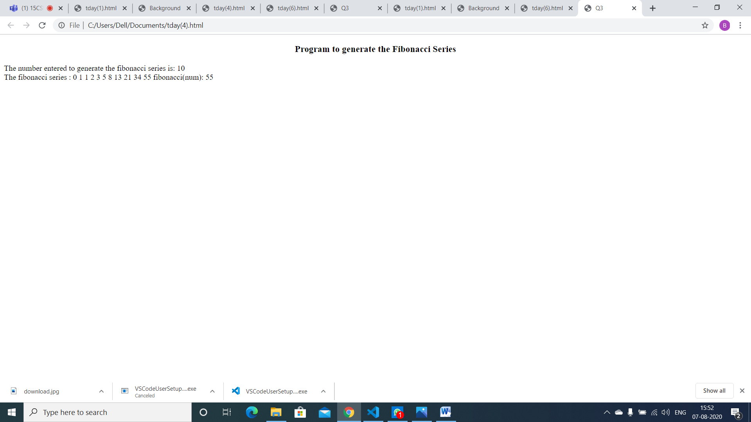

5 question :

<!DOCTYPE HTML>

<?xml version="1.0" encoding="UTF-8"?>

<html>

<head>

<title> Q5 </title>

</head>

<body style="background-color:white">

<script type="text/javascript">

 function sort(names)

{

    return names.sort();;

}

var names = prompt("Enter names").split(",")

 document.write("sorted names are: "+sort(names)+"<br>");

</script>

</body>

</html>

Output:

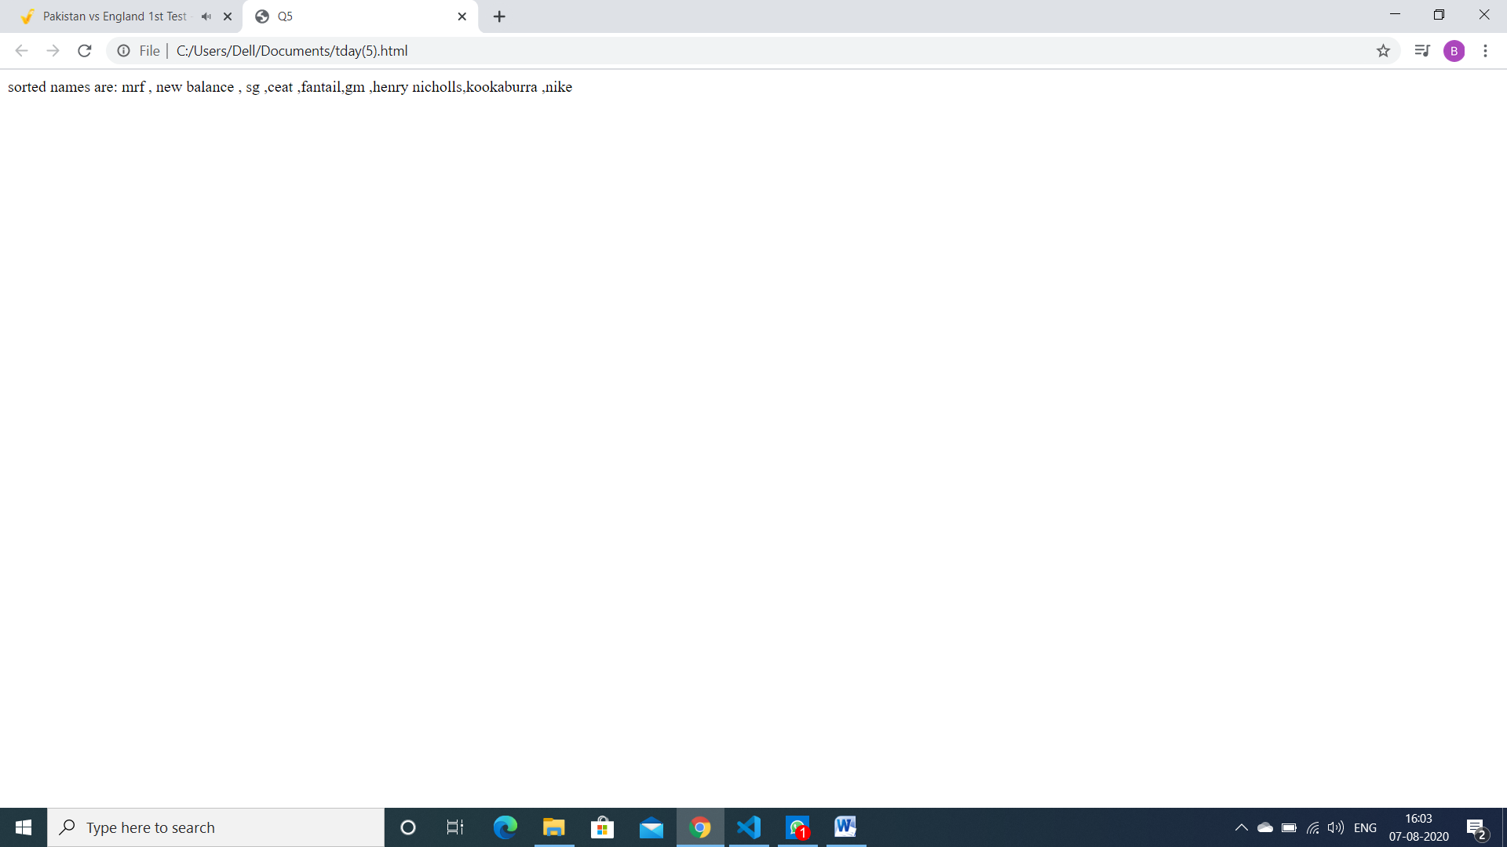

3 question :

<!DOCTYPE html>

<html lang="en">

<head>

    <meta charset="UTF-8">

    <meta name="viewport" content="width=device-width, initial-scale=1.0">

    <title>Document</title>

</head>

<body>

    <img src="logo.jpg" usemap="#map" >

    <map name="#map">

        <area shape="rect" coords="0,0,270,400" onmouseover="left()" onmouseout="out()" onclick="imageClick()">

        <area shape="rect" coords="270,0,550,406" onmouseover="right()" onmouseout="out()" onclick="imageClick()">

    </map>

    <p id="popup">place cursor on image</p>

</body>

<script>

    function left()

    {

        document.getElementById("popup").innerText="Left Side of Logo"

    }

    function right() {

        document.getElementById("popup").innerText = "Right side of Logo"

    }

    out()

    {

        document.getElementById("popup").innerText= "place cursor on image"

    }

    function imageClick()

    {

        window.open("bigImage.html")

    }

</script>

</html>

:

Output :

